**CST 8285_Group 6 Assignmen2**

**Expense Tracker Pro**

**Team Member:**

Mutao Yin 041025809

Dongni Du 040621347

Xiaozhou Liu 040857626

Web map

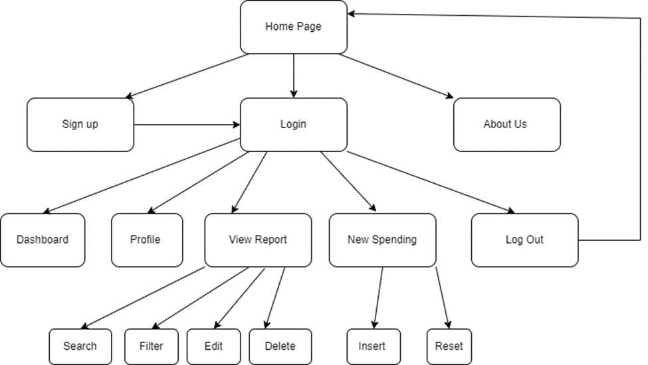

Wireframe

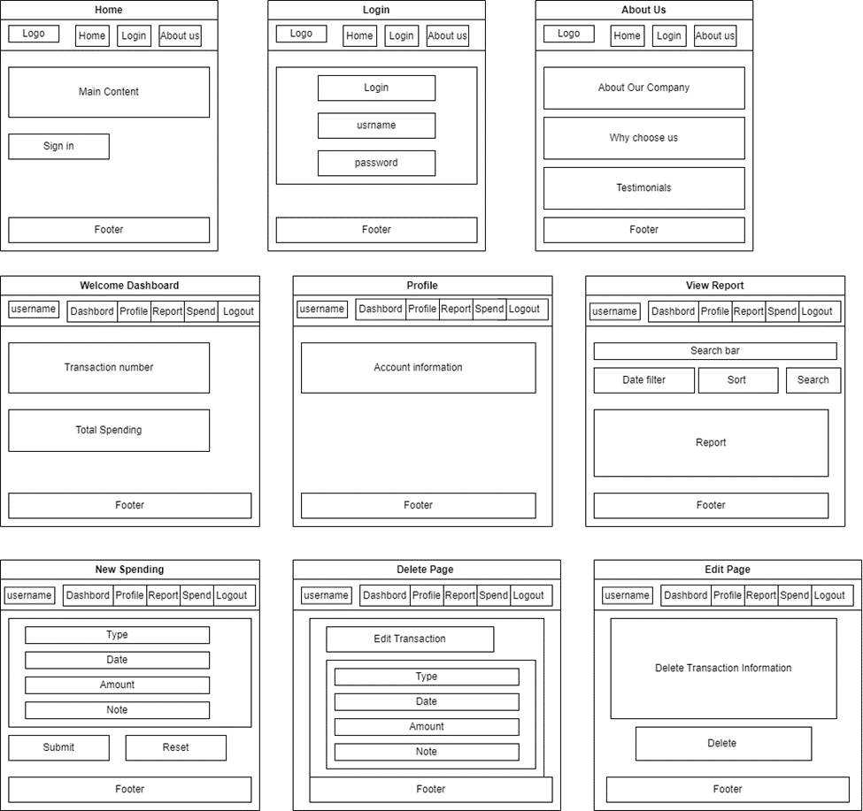

Functionality guide

1. Visit the Website Home page, new users can click “About Us” to realize our company and then click “Sign up” bottom to create a new account.
2. When a new user “Sign up”, they need to fill up “First name”, “Last name”, “Valid Email” and “Password”.
3. After Signing up for a new account or existing user, you can click the Home page “Login” icon, then go to the login page to sign in.
4. When a user signs in successfully, a “Welcome page” will show up, this page includes several icons:

a) Dashboard: show the user’s transaction numbers and the total amount

b) Profile: show the user’s account information

c) View Report: users can realize their expense report on this page, and search or filter the expense details according to different conditions. In addition, users can edit or delete their expense details in the report by clicking the “Edit” or “Delete” icons at the end of each record line.

d) New expense: user can add new expenses including, expense type, date, and amount, and also can add a note as well.

5. When a user finished all the modifications, can click the “log out” icon to sign out.

Description of the database

Our “[expense_tracker_pro](http://localhost/phpmyadmin/index.php?route=/database/structure&db=expense_tracker_pro)” database has three tables, transactions, types and users table.

One user can have many transactions, one transaction just has one type.

Transaction Table: Record user’s spendings

Types Table: Identify type of spendings

Users Table: Record user profile

Database definition code (DDL for the tables)

CREATE TABLE `transactions` (

`id` int(11) NOT NULL,

`userId` int(11) NOT NULL,

`date` date DEFAULT NULL,

`amount` float NOT NULL,

`typeId` int(11) NOT NULL,

`notes` varchar(100) NOT NULL

) ENGINE=InnoDB DEFAULT CHARSET=utf8mb4;

CREATE TABLE `types` (

`id` int(11) NOT NULL,

`name` varchar(20) NOT NULL

) ENGINE=InnoDB DEFAULT CHARSET=utf8mb4;

CREATE TABLE `users` (

`id` int(11) NOT NULL,

`firstName` varchar(10) NOT NULL,

`lastName` varchar(10) NOT NULL,

`email` varchar(20) NOT NULL,

`password` varchar(10) NOT NULL

) ENGINE=InnoDB DEFAULT CHARSET=utf8mb4;

ALTER TABLE `transactions`

ADD PRIMARY KEY (`id`),

ADD KEY `typeId` (`typeId`),

ADD KEY `userId` (`userId`);

--

-- Indexes for table `types`

--

ALTER TABLE `types`

ADD PRIMARY KEY (`id`);

--

-- Indexes for table `users`

--

ALTER TABLE `users`

ADD PRIMARY KEY (`id`);

--

-- AUTO_INCREMENT for dumped tables

--

-- AUTO_INCREMENT for table `transactions`

--

ALTER TABLE `transactions`

MODIFY `id` int(11) NOT NULL AUTO_INCREMENT, AUTO_INCREMENT=10;

--

-- AUTO_INCREMENT for table `types`

--

ALTER TABLE `types`

MODIFY `id` int(11) NOT NULL AUTO_INCREMENT, AUTO_INCREMENT=4;

--

-- AUTO_INCREMENT for table `users`

--

ALTER TABLE `users`

MODIFY `id` int(11) NOT NULL AUTO_INCREMENT, AUTO_INCREMENT=4;

--

-- Constraints for dumped tables

--

-- Constraints for table `transactions`

--

ALTER TABLE `transactions`

ADD CONSTRAINT `transactions_ibfk_1` FOREIGN KEY (`typeId`) REFERENCES `types` (`id`),

ADD CONSTRAINT `transactions_ibfk_2` FOREIGN KEY (`userId`) REFERENCES `users` (`id`);

COMMIT;

Breakdown of the tasks assigned to each team member

| Team Member | Tasks |
| --- | --- |
| Mutao Yin, Dongni Du, Xiaozhou Liu | Website Architecture Design |
| Mutao Yin | Website CSS Design |
| Mutao Yin | Home page create and operate realization |
| Dongni Du | Database creation and operation realization |
| Dongni Du, Mutao Yin | Login page creation and operation realization |
| Xiaozhou Liu, Dongni Du | Sign up page creation and operation realization |
| Dongni Du | Report page creation and operation realization |
| Xiaozhou Liu | Spending page creation and operation the realization |
| Mutao Yin | Welcome page, User home page, Profile page, About Us page create and operate realization |
| Xiaozhou Liu | Project document |
|  |  |
|  |  |